Mars Industrialisation
Technical Reference
Engineering Architecture, Compression Moves, and Failure Modes
Document 3 of 6 in the Building Mars set
May 2026

Audience and Scope
This document is the technical reference for the integrated Mars industrialisation thesis. It is written for engineers, technical analysts, programme managers, and informed technical readers who want to evaluate the engineering pathway in detail. It assumes familiarity with space-systems concepts and does not explain basic terms.
The document covers the architecture (six-layer industrial stack), the timeline arithmetic (why 50 years baseline, how compression to 25 years is claimed), the eight specific compression moves and their failure modes, the phased plan, the hard problems including the semiconductor wall, and the technical risk register including failure-after-success scenarios.
What this document does not cover: the financial case (Document 1), the policy and regulatory framework (Document 2), the structural and ethical critique (Document 4), or the philosophical questions (Document 6). Technical readers concerned about whether the project should happen on broader grounds should engage Documents 4 and 6 in addition to this one.
The document is hedged where the technical claims are contested. Advocate framing and critic framing are both presented where they diverge. Phrases like "advocates argue" and "critics argue" are used where there is genuine disagreement among informed analysts; phrases like "this requires" and "the constraint is" are used where the claim is empirically settled.

1. The Honest Baseline
Before discussing acceleration, the calendar from first principles. A conventional, well-funded Mars industrialisation programme using standard aerospace methods produces roughly 50 years from serious start to mature off-world industrial capability. The constraints below are what produce that timeline.

1.1 The Launch Window Cadence
Mars and Earth align favourably for low-energy transfers approximately every 26 months. This is set by orbital mechanics; better engines do not change it. Launching outside the optimum window incurs a steep propellant penalty that translates to mass on the surface. Mars activity is paced by these windows.
A 10-year programme is approximately five iteration cycles. Earth-side iteration cycles are weeks to months; lunar cycles (post-Artemis) are days. The 26-month Mars cycle is the dominant feature of any timeline calculation. Missing a window costs 26 months and missing windows is the historical norm rather than the exception.

1.2 Mass to Surface
Starship, fully reusable, is projected to deliver roughly 100 tons of payload to the Martian surface per launch. SpaceX cites higher figures of up to 150 tons reusable and 250 tons expendable for full system maturity, but operational reality has typically tracked behind public projections.
At 50 Starships per launch window with 100 ton average payload — itself an aggressive assumption — the surface delivery rate is 5,000 tons per window or roughly 2,000 tons per year averaged across windows. A modest terrestrial factory weighs tens of thousands of tons; a serious industrial complex weighs hundreds of thousands. The mass budget is genuinely tight and shapes everything downstream.

1.3 The Power Wall
Mars receives approximately 43% of Earth's solar irradiance at the top of its atmosphere; surface dust storms can reduce this further for weeks. Solar power is feasible but not abundant. Industrial activity at scale — particularly metallurgy, fundamentally about moving large quantities of energy through ore — needs nuclear power. Section 7 examines the April 2026 NSTM-3 directive in detail; the recalibrated framing is that 2030 marks the beginning of launch-rated nuclear flight heritage at the 20–100 kWe scale, with megawatt-class deployments arriving mid-2030s rather than 2030 as some early readings of NSTM-3 implied.

1.4 Construction Tempo
On Earth, a large factory takes 2–5 years to build with thousands of workers, unlimited supply chains, and continuous human oversight. On Mars, with robots only, no real-time control due to the 4–24-minute light lag, dust, temperature swings from −80°C to +20°C, and 26-month resupply gaps, construction is 3–10 times slower at minimum. The faster figures assume autonomy that has not yet been demonstrated in the relevant environment.

1.5 The Resulting Baseline
Stacking these constraints produces a roughly 50-year programme: 5 years of robotic precursors, 5 years of initial deployment, 10 years of scale-up, 15 years of maturation, 15 years to approach local sufficiency. Recognisable factory appears around year 15–20; mature industrial capability around year 30–35.
The interesting engineering question is which of these years are recoverable. Roughly 15 years are hard physics (launch windows, mass budget, light lag, surface conditions); roughly 35 years are potentially recoverable through better execution, integration, and architectural choices. Section 3 examines the eight specific moves that advocates claim can recover most of the 35 years.

2. The Six-Layer Industrial Stack
A defensible Mars programme is not invented from scratch. It is integrated from six already-funded industrial markets, each developing rapidly for its own commercial reasons. The stack diagram below shows the layers and indicative companies; details and acquisition rationale are in Document 7.
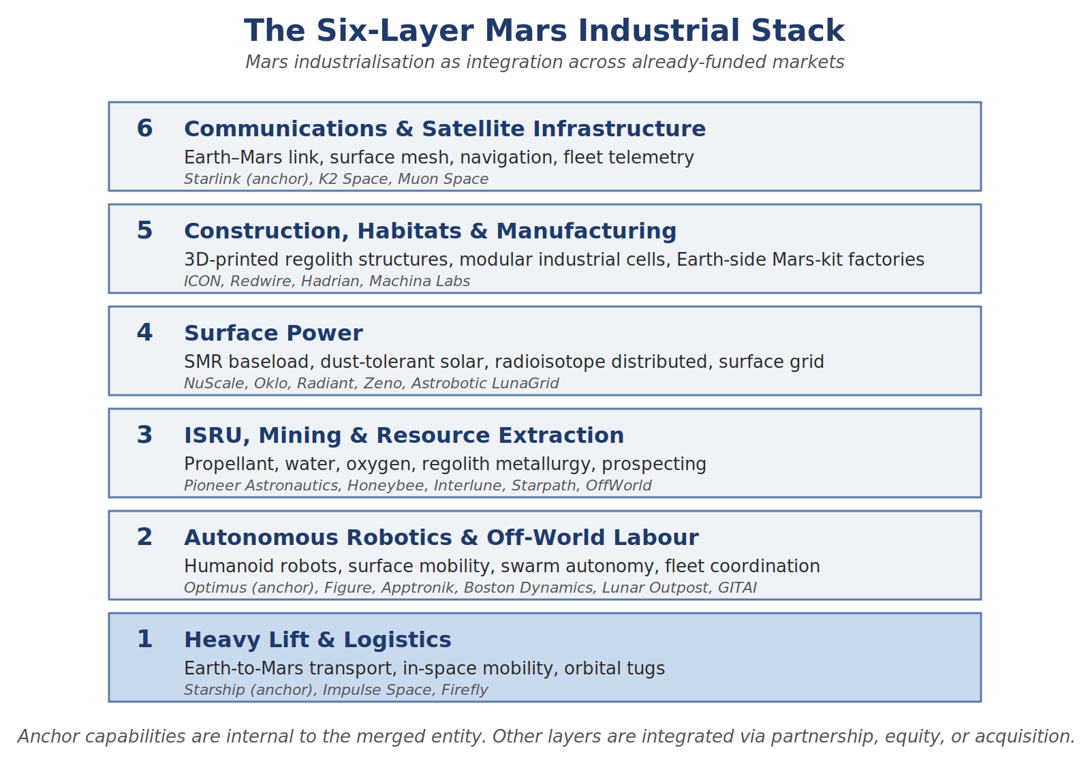
Figure 1. The six-layer Mars industrial stack. Anchor capabilities are internal to the operating entity; other layers are integrated via partnership, equity, or acquisition.

2.1 Layer 1 — Heavy Lift and Logistics
SpaceX Starship is the anchor system. There is no alternative within the relevant timeline. Starship's projected payload is the only architecture that fits the mass requirements. The technical risk is not payload size but cadence, refuelling, reliability, and Mars surface delivery — each of which has not been fully demonstrated.
Starship alone is not sufficient. Orbital logistics — space tugs, cargo transfer, depot operations, rendezvous and assembly — are also required. Impulse Space (founded by former SpaceX propulsion lead Tom Mueller, ~$525M total capital) provides in-space mobility. Firefly Aerospace and Stoke Space provide medium-lift complementary capability.

2.2 Layer 2 — Autonomous Robotics and Off-World Labour
Tesla Optimus is the planned construction workforce. The broader humanoid robotics ecosystem provides additional autonomy capability that should be integrated rather than reinvented. Figure AI ($1B+ Series C September 2025 at $39B post-money), Apptronik (>$935M Series A with Mercedes/Google partnerships), Boston Dynamics (Hyundai-owned), and Lunar Outpost ($30M Series B May 2026, 8 contracted lunar missions through 2030) are the principal autonomy suppliers.
The technical question is whether consumer-grade humanoid robots can be successfully Mars-spec'd. The differences are substantial: actuators must operate from −80°C to +20°C; electronics must survive radiation; sealing must prevent dust intrusion; power systems must accommodate intermittent solar; mean-time-between-failures must be measured in months rather than weeks. Each of these is solvable in principle; whether all are solvable simultaneously at consumer-electronics manufacturing economics is the core technical question.
The capital flows in humanoid robotics are largely subsidising what a Mars programme would otherwise have to fund itself. The autonomy stack required for Mars is being developed for warehouses, factories, and homes by companies with multi-billion-dollar valuations.

2.3 Layer 3 — ISRU, Mining, and Resource Extraction
In-situ resource utilisation is the technology base for everything that follows. Key technologies and players:
- Sabatier methane synthesis (CO₂ + H₂ → CH₄ + H₂O): mature laboratory; pilot scale not demonstrated on Mars.
- Water extraction from regolith (subsurface ice, hydrated minerals): demonstrated at small scale; industrial scale not demonstrated.
- Oxygen generation (electrolysis of water; direct atmospheric processing): MOXIE on Perseverance demonstrated atmospheric route at ~10 g/hr. Industrial scale requires 10⁵× scale-up.
- Regolith metallurgy (extracting iron, aluminium, magnesium, silicon): Pioneer Astronautics MMOST process demonstrated for iron and steel; broader metals less developed.
- Construction materials (sintered regolith, Olympus 3D printing): ICON has substantial NASA contract for development through 2028.
Key players: Pioneer Astronautics (NASA SBIR Phase III, MMOST oxygen + steel from regolith), Honeybee Robotics (Blue Origin subsidiary, Mars drilling/sampling flight heritage going back to 2004), Interlune ($6.9M NASA SBIR Phase III 2026 for lunar prospecting), Starpath Robotics ($12M seed for lunar oxygen production), OffWorld (autonomous mining robotics with NASA support).

2.4 Layer 4 — Surface Power
The April 14, 2026 NSTM-3 directive fundamentally changes the regulatory environment. Carefully read, it mandates: NASA mid-power lunar fission reactor (≥20 kWe, extensible to 100 kWe) by 2030; DoD orbital reactor by 2031; DoE/DoD assessment of US industrial base for space-rated nuclear; NRC/FAA streamlined licensing. There is no Mars-specific deliverable, and megawatt-class systems are contemplated as future extensions but not mandated for any specific date.
Recalibrated nuclear timeline for Mars:
- 2028–2030. Mars Yard 2 demonstrates 100 kWe-class systems on Earth using lunar-reactor heritage.
- 2030. Federal lunar reactor (20+ kWe) launches and operates. Flight heritage established.
- 2031. First DoD orbital reactor operates. NRC/FAA pathway proven.
- 2031–2033. First Mars surface deployment of 100 kWe-class units, with multiple redundant reactors per site.
- 2033–2036. Megawatt-class units deploy on Mars.
- Late 2030s. Multi-megawatt Mars surface power infrastructure operational across multiple sites.
Vendors: NuScale (only NRC-approved SMR design, 77 MWe), Oklo (Sam Altman backing, ~$1.8B total funding, Meta 1.2 GW campus deal), X-energy (Amazon-backed, TRISO-fuelled), Radiant Nuclear (>$300M for Kaleidos 1 MWe transportable), Zeno Power ($50M Series B, americium-241 RPS), Astrobotic LunaGrid ($34.6M NASA Tipping Point).
A mature Mars site needs hybrid architecture: nuclear baseload (multiple SMR units, 1–10 MWe class, redundant), solar peaking (large arrays with dust mitigation), radioisotope distributed (Zeno-class for always-on small loads and dust-storm survival), storage (battery + methane-oxygen fuel cells), and distribution (LunaGrid-class technology). Total capital investment in Mars surface power: $30–60B over 25 years.

2.5 Layer 5 — Construction, Habitats, and Manufacturing
ICON received a $57.2M NASA SBIR Phase III contract in 2022 (running through 2028) to develop the Olympus construction system for Moon and Mars. Mars Dune Alpha, the 1,700-square-foot 3D-printed habitat used for NASA's CHAPEA missions, is the most developed surface construction technology.
Redwire received NASA approval in 2025 to advance manufacturing technologies for Moon and Mars infrastructure, with the FabLab effort targeting multi-material manufacturing.
Earth-side Mars supply-chain manufacturing: Hadrian (Series C $260M, robotic factories for aerospace), Machina Labs (Series C $124M 2026, robotic manufacturing of large metal parts). Strategic distinction: Mars-side manufacturing (what Optimus and ICON do on the surface) versus Earth-side Mars-supply-chain manufacturing (what Hadrian and Machina Labs do producing standardised kits). Both are required.

2.6 Layer 6 — Communications and Compute
Starlink is the primary communications layer for Earth-to-Mars and Mars-orbital relay. Mars-Starlink is a logical extension: a constellation in Mars orbit providing surface communications, navigation, and Earth-relay capability. K2 Space ($250M Series C at $3B valuation) builds large high-power satellite buses for the heavy-lift era. Muon Space integrates Starlink Mini space lasers and expands constellation manufacturing for sensing and optical communications.
Mars-specific communications architecture combines elements: surface mesh networking, orbital relay, optical inter-satellite links, local positioning, robot fleet telemetry, delay-tolerant autonomy. None is exotic; all require integration.

3. The Eight Claimed Compression Moves
Advocates claim that, stacked together with consistent execution, eight specific moves compress the conventional 50-year baseline into roughly 25 years. None requires a breakthrough not currently visible. Each move and its principal failure mode are below.

3.1 Front-Load Mass Before Humans Matter
Conventional Mars plans pace the buildup around eventual human arrival, forcing life-support priorities to dominate early payload mass. If the first 10–15 years are declared explicitly pre-human, every kilogram of payload can be devoted to robots, power, feedstock processors, and manufacturing equipment. Roughly doubles useful industrial payload per launch.
Failure mode. Political pressure to bring humans forward overwhelms the engineering case. Most public excitement about Mars is about humans on Mars; a programme that postpones humans for fifteen years faces sustained political pressure. The compression is engineering-real but politically fragile.

3.2 Massively Parallel Deployment
The slow version sends tens of robots in early windows. The fast version sends thousands in the first window where Starship is reliably operational. Advocates project SpaceX hitting aircraft-factory rates for Starship and Tesla hitting car-factory rates for Optimus. Even a small fraction of these production targets diverted to Mars produces unprecedented deployment scale.
Failure mode. Manufacturing scaling falls short. SpaceX's historical rate of Starship achievement has tracked behind initial public targets; Tesla's production targets for Optimus were originally set for years that have passed. The compression depends on both organisations executing better than their historical pattern suggests. If Starship reaches only 25 launches per Mars window with 60-ton payloads, the deployment scale is inadequate for the timeline.

3.3 Prefab Everything Possible
Do not build a factory on Mars. Ship a factory to Mars. Modular industrial units — metallurgy module, parts-fabrication module, power module, chemistry module — designed to land, deploy with minimal robot intervention, and start operating within days. Shipping-container-scale industrial cells, each pre-tested on Earth, each with standardised interfaces.
Failure mode. Mars conditions surface design problems that Earth testing did not predict. Module-level redesigns are 26-month cycles. The compression assumes most prefab designs work first time; historically, this assumption has been wrong for most novel space systems.

3.4 Earth-Side Dress Rehearsal (Mars Yard 2)
A purpose-built closed-environment facility with Mars-spec atmospheric composition (mostly CO₂, low pressure) and regolith simulant in industrial quantities. Large enough to house a full-scale ISRU pilot plant and operate it 24/7 with the actual robots and software that will go to Mars. Estimated investment $5–10B over five years. Locate in a high-altitude desert (Atacama, Chilean or US Southwest) for thin atmosphere and UV exposure analogue, with a sister facility in Antarctica for cold and isolation.
Failure mode. Earth analogues have repeatedly failed to predict actual surface failure modes. Every Mars rover that died had survived its Earth qualification. Confidence in this move should be moderate rather than high. The compression is real but smaller than advocates claim.

3.5 Lunar Parallel (Mars Yard 3)
Earth analogues cannot simulate vacuum, hard radiation, or reduced gravity. The Moon serves as final test environment. Before committing thousands of humanoid robots to the 2031 Mars window, deploy a beta-fleet of perhaps 500 to the lunar surface in 2029 to construct Artemis infrastructure. Operating ISRU, drilling, dust mitigation, and continuous abrasive material handling on the Moon — even though lunar regolith chemistry differs from Mars — exposes mechanical failure modes that Mars Yard 2 cannot simulate.
Three-day Earth-Moon transit allows iteration in days rather than 26 months. Replacement parts can be sent quickly. Lessons feed back into Mars-bound hardware design with months rather than years of latency.
Failure mode. Lunar regolith and Mars regolith differ enough that some failure modes will not transfer in either direction. The lunar programme has its own demanding schedule and cannot be assumed to serve Mars goals as a free side effect. Coordination overhead between programmes can offset some of the iteration-speed benefit.

3.6 AI-Driven Design Iteration
AI does not build factories on Mars. AI does enable simulation-based design optimisation at rates humans cannot match: generative design of structural components, materials science discovery for novel alloys, control system optimisation for autonomous robots, failure mode prediction across complex systems. Advocates project 30–50% R&D acceleration across the programme.
Failure mode. AI acceleration extrapolates from narrow domains (chip layout, certain materials problems) where AI has clearly accelerated work to broader systems integration where AI's record is much weaker. The historical pattern of "this new technology will accelerate everything" has produced repeated over-projection. Realistic acceleration is probably 10–25% rather than 30–50%.

3.7 Iterate in Production
Standard aerospace practice is exhaustive testing and qualification cycles measured in years. SpaceX has demonstrated, with both Falcon and Starship, that an alternative methodology — iterate in production, expect early failures, fix in version two — produces faster overall progress when units are cheap enough to lose. Applied to Mars: build version one expecting substantial problems. Lose perhaps 30% of robots to bugs, dust, and surprises. Use the failure data to drive version two.
Failure mode. Iterate-in-production works on Earth because failed prototypes can be examined, the failure mechanism understood, and the next iteration shipped quickly. None of these conditions hold on Mars. A failed Mars robot is examined remotely if at all, the failure mechanism may not be diagnosable, and the next iteration is 26 months away. The methodology may not transfer.

3.8 Pre-Position Cargo
Use every Mars window starting immediately to send precursor payloads — sensor packages, regolith samplers, prototype ISRU units, communications relays. Each precursor mission de-risks something for the main buildout. The 2026 window is essentially gone for serious payloads, but the 2028 window is reachable if commitment is made now.
Failure mode. Precursor missions test specific subsystems but cannot test integrated operation at scale. Surprises that emerge at scale (system-level failure modes, supply chain dependencies) are not pre-de-risked. The compression is real but limited.

3.9 Stacking Discipline
Each move alone produces modest acceleration. Advocates argue stacked together with consistent execution they produce substantial acceleration. Critics argue the multiplicative claim is misleading: consistent execution of eight independent moves over 25 years is not a single bet but eight bets in series, and the joint probability of all eight executing as projected is substantially lower than the sum of individual probabilities suggests.
A defensible technical view: each move recovers some fraction of its claimed benefit, the cumulative effect is meaningful but smaller than the headline 25-year aggressive timeline implies. A realistic central estimate is 30–35 years rather than 25 years. The 25-year case requires unbroken favourable execution; the 50-year baseline requires nothing extraordinary. The truth is probably between.

4. The Phased Plan
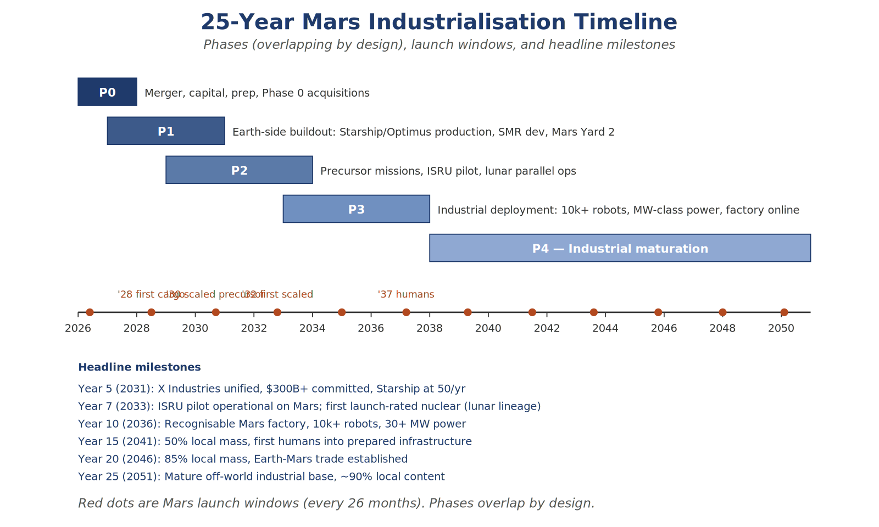
Figure 2. The 25-year industrialisation timeline, advocate base case. Conservative case stretches each phase by 5–10 years.

4.1 Phase 0 — Corporate, Capital, and Policy Foundations (Years 0–2)
Earth-side foundations. Corporate structure execution (under whichever governance option is chosen). Capital campaign across sovereign, public market, project finance, government, and strategic categories. Initial acquisitions and partnerships across the six layers, total integration cost $14–35B. Policy track on planetary protection, nuclear advocacy, international engagement, antitrust posture. Mars Yard 2 site selection and design. Engineering team build-out to ~10,000 headcount in Off-World Industry division.
Phase 0 is execution risk on the corporate and financial structure, not the technology. The technical work begins later. Phase 0 failure (merger blocked, capital insufficient, key acquisitions fail) cascades into all later phases.

4.2 Phase 1 — Earth-Side Buildout (Years 1–4)
Targets:
- Starship production at 50+/yr by year 5, 200/yr by year 8.
- Mars-spec Optimus production at 50,000/yr by year 6.
- Cost target for Mars-spec Optimus: under $200K fully built, ideally under $100K.
- Mars-spec SMR development with NuScale/Oklo, NRC certification track in parallel.
- Mars Yard 2 operational, conducting 24/7 integrated systems tests.
- ISRU technology consolidated under Off-World Industry; flight-readiness funding.
Phase 1 is principally manufacturing scale-up. The technical challenge is hitting the production rates and unit-cost targets for both Starship and Optimus. Both are achievable in principle but require execution beyond what either organisation has historically delivered on schedule.

4.3 Phase 2 — Precursor Missions and Lunar Parallel (Years 3–7)
2028 window. First real precursor opportunity. Payload: 5–10 cargo Starships, ~500–1,000 tons. Composition: sensor packages and surface mapping; regolith samplers; communications relay (initial Mars-orbital constellation); prototype small-scale ISRU units for methane and water; small Optimus deployment (50–200 units) plus Lunar Outpost MAPP-class rovers; multi-hundred-kilowatt solar prototypes; Zeno-class radioisotope power units.
Mission objectives: characterise surface environment in detail, identify and confirm water ice deposits, demonstrate end-to-end ISRU at small scale, prove integrated robot operations in actual Mars conditions. Success criteria are deliberately modest — this is a learning mission.
2029–2030 lunar parallel. Beta-fleet of 500 Mars-spec Optimus units to lunar surface for Artemis support. Vacuum operation experience, reduced-gravity behaviour, thermal cycling at extreme amplitudes, dust electrostatic effects, multi-vehicle coordination. Three-day transit allows fast iteration. Partly self-funding through Artemis contracts.
2030 window. Substantially scaled-up Mars deployment. 20–30 cargo Starships, 2,000–3,000 tons. Full ISRU pilot plant; Optimus deployment 1,000–2,000 units; prototype Olympus habitat structures; first multi-megawatt solar farm with dust mitigation; pre-positioning of structural materials; first nuclear power deployment (20–100 kWe class drawing on lunar reactor lineage).
By Phase 2 end, the programme has 60–80% confidence in the Phase 3 architecture — high enough to commit to the much larger Phase 3 deployment. If precursor missions surface fundamental architecture problems, Phase 3 must be paused and rearchitected.

4.4 Phase 3 — Industrial Deployment (Years 7–12)
2031 window. 50+ cargo Starships, 5,000–7,500 tons. 10,000–15,000 Optimus units organised into specialised teams. Multiple 100-kWe-class power units for redundancy plus solar farms. Complete prefab industrial modules: metallurgy cells, parts fabrication cells, ISRU at scale, water mining, electrolysis, basic chemistry. Site A primary infrastructure begins construction.
2033 window. Another 10,000–20,000 Optimus units with second-generation hardware reflecting field-proven modifications. First megawatt-class nuclear deployment. Manufacturing equipment for next localisation tier: more sophisticated metallurgy, polymer production from atmospheric CO₂ and hydrogen, basic electronics fabrication (PCBs and simple components). Major expansion of Site A; Sites B and C reach operational scale. Beginning of intersite logistics infrastructure.
2035 window. Third-generation Optimus units. Specialised hardware for next localisation phase: motor assembly capability, sensor manufacturing, more sophisticated electronics, polymer-based structural components. Major energy infrastructure expansion to 30–50+ MW across multiple reactor units. Habitat shells for eventual human arrival.
Biological precursor integration (Phase 3 windows). Small but critical mass fraction devoted to autonomous biological preparation. Martian regolith contains high concentrations of toxic perchlorates; automated systems must wash, remediate, and biologically activate local regolith into viable agricultural soil. Small-scale autonomous bioreactors and enclosed greenhouses by 2033 window. Cultivating biological material acts as biosensor: genetic degradation or stability of crops over Mars years validates radiation shielding for eventual human crews.
Phase 3 end state: 50,000+ Optimus units across 3–5 sites, 30–80 MW power capacity (mostly nuclear), industrial production of 10,000+ tons/year of methane/oxygen, 1,000+ tons/year of structural metals from regolith, basic manufacturing of structural components. Localisation: ~30% of operational mass produced locally. Cumulative capital deployed: $400–600B.

4.5 Phase 4 — Industrial Maturation (Years 12–25)
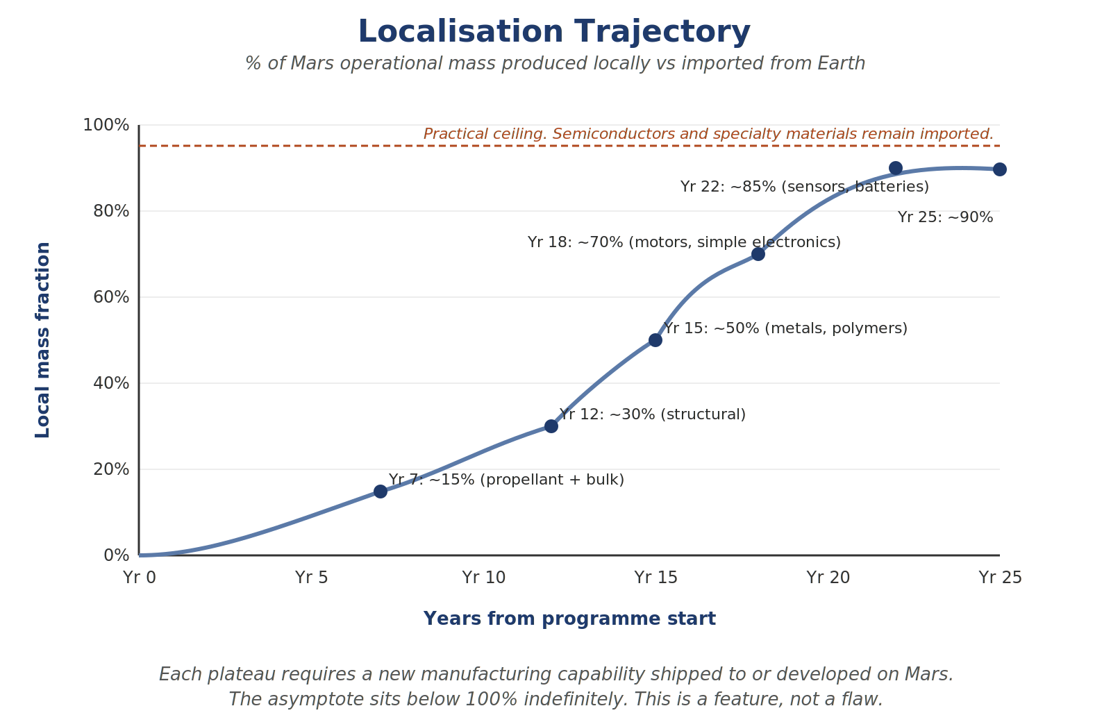
Figure 3. Localisation trajectory. Each plateau requires new manufacturing capability. The asymptote sits below 100% indefinitely.
Localisation trajectory: 30% by year 12 → 50% by year 15 → 70% by year 18 → 85% by year 22 → 90% by year 25. Each step requires substantial new manufacturing capability.
Operational scale: 8–12 sites by year 25, workforce of 300,000–500,000 Optimus units, power capacity in the gigawatt range. Site specialisation emerges: metallurgy and heavy industry hub, chemistry and polymer hub, assembly and manufacturing hub.
Human arrival: probably year 15–17. Initial crews 10–30 people on 2-year tours. Role: exception handling, scientific research, seeds for eventual permanent presence. Robots have done construction; humans operate, do science, live there. By year 25, low hundreds of permanent residents.
Circular Mars economy: standard aerospace practice treats failed hardware as garbage. Incompatible with Mars mass constraints. Phase 4 introduces deep-recycling: modular cannibalisation, reclamation of structural metals, melting down scrapped chassis for re-use. Module-level replacement for complex semiconductors means Earth continues to ship high-density compute modules; recycling infrastructure ensures physical bulk (steel, glass, polymers) remains in closed loop.

5. The Semiconductor Wall
The localisation trajectory approaches but never reaches 100%. The asymptote is real and principally about semiconductors.

5.1 Why Semiconductors Are Special
Modern semiconductor manufacturing is the most demanding industrial process humanity has developed. A leading-edge logic process (3 nm or below as of 2026) requires extreme ultraviolet lithography machines costing $200+ million each, manufactured by a single company (ASML), drawing on supply chains spanning dozens of countries and tens of thousands of specialised inputs. The wafer fabrication process involves hundreds of process steps, each with its own equipment, chemistry, and contamination control requirements.
Total industrial complex required for a single leading-edge processor is, by any reasonable measure, the most concentrated in human industry. Three or four full leading-edge fabs in the world (TSMC Taiwan, Samsung Korea, Intel ramping multiple sites, smaller capacity at SMIC China). Each costs $20–40B to build. Each takes 3–5 years to construct from prepared site.
Localising this on Mars is not a multi-decade project. It is a multi-century project, possibly indefinite. The cost of building a leading-edge fab on Mars would dwarf the entire programme described in this document, and the sustaining infrastructure (specialty chemicals, replacement parts, calibration equipment) would multiply that cost continuously.

5.2 The Practical Strategy
Mars semiconductors are imported indefinitely. The architecture accommodates this:
- Modular replacement. All compute, sensors, and electronics designed for modular replacement. When a semiconductor component fails, the module containing it is removed and replaced as a unit.
- Compute consolidation. Compute consolidated into a smaller number of high-density facilities rather than distributed across every device. Minimises total semiconductor mass and maximises efficiency of import pipeline.
- Trailing-edge tolerance. Many Mars applications do not require leading-edge semiconductors. Industrial control, sensor processing, most autonomy compute work well on 14 nm, 28 nm, or older processes. Trailing-edge fab capability (90 nm or 180 nm) is achievable on Mars in late Phase 4 or Phase 5, addressing 20–40% of total semiconductor needs.
- Earth-side stable supply. Long-term supply contracts for Mars-spec components, similar to how automotive companies secure long-term semiconductor supply.

5.3 The Earth Dependency
The semiconductor wall means Mars is not, in any foreseeable future, independent of Earth. A Mars colony cut off from Earth supply would degrade over time as semiconductors fail and cannot be replaced. Degradation timeline is years to decades depending on inventory management and trailing-edge production localisation.
This is not a flaw of the plan; it is a feature of physical reality. The "civilisational backup" motivation requires qualification: Mars provides redundancy against many failure modes, but full Earth-civilisation collapse would, over decades, also degrade the Mars colony absent dramatic localisation efforts not contemplated in any current plan.

6. Technical Risk Register
Risks to the technical programme, organised by severity and probability. The high-severity, high-probability risks at the top.
Risk | Severity | Probability | Mitigation
Starship cadence below assumed | Critical | Medium | Conservative payload assumptions; second factory; backup architectures
Robot reliability failure on Mars | Critical | Medium-low | Lunar parallel; Mars Yard 2; precursor missions; expected 30% loss rate
ISRU underperformance at scale | High | Medium | Precursor proving missions; multiple sites; lab work continues
Major launch failure with cascade effects | High | Low-medium | Multiple launch sites; payload distribution; insurance
Major dust storm during critical phase | Medium | Medium-high | Multiple sites; nuclear baseload; storm-tolerant designs
Cyber-physical attack on autonomy stack | Medium | Low-medium | Air-gapped domains; diverse vendors; hardware kill-switches
Semiconductor supply shock | Medium | Low-medium | Long-term supply contracts; strategic stockpiles; vendor diversification
HALEU fuel constraint | Medium | Medium | Phase 0 advocacy for fuel production capacity
Acquisition / cultural integration failure | High | Medium-high | Friendly transactions; retention packages; dedicated integration leadership

Capital and political risks (capital discontinuity, political reversal, antitrust) are addressed in Documents 1 and 2. They are at least as material as the technical risks above for overall programme outcome.

7. Failure Modes and Falsification Markers

7.1 Programme-Failure Modes
Beyond individual risks, the principal ways the entire programme could fail technically.
Manufacturing scaling failure. SpaceX or Tesla cannot reach the production rates the plan requires. Programme stretches by 5–15 years; possibly fundamentally infeasible at the headline scale.
Autonomy stack collapse. Mars-spec robots fail at much higher rates than expected (70%+ versus 20–40% planned). Autonomy cannot operate the surface industrial base without continuous human oversight that is impossible at light-lag distance. The plan does not work in current form; rearchitecture required.
ISRU industrial-scale failure. Sabatier and regolith metallurgy work in laboratory but cannot reach industrial scale. Localisation trajectory wrong; Mars remains an outpost rather than factory.
Nuclear regulatory reversal. NSTM-3 reversed or substantially slowed. Mars surface nuclear arrives 5–10 years later than planned at smaller scale.
Cumulative slippage. Each individual risk recovered, but cumulative effect of multiple smaller-than-fatal slips makes the timeline meaningless. 25-year aggressive becomes 40-year quiet failure.

7.2 Failure-After-Success Modes
Distinct from failures of the programme: ways the programme can succeed technically while producing harmful systemic effects. Document 4 examines these in detail; they are flagged here because technical readers should be aware that "the programme works" is not equivalent to "the outcome is good."
Six scenarios meet the threshold of having operational detail equivalent to the success scenario: corporate capture of off-world activity, militarisation of cislunar infrastructure, stranded trillion-dollar infrastructure (Phase 4 capital deteriorates), political fragmentation between Earth and Mars, ecological contamination event, authoritarian governance in closed habitats. Each is concrete and probability-bounded; readers concerned about the broader impact of technical success should engage Document 4.

7.3 Falsification Markers
Markers that would indicate the technical programme is off track. Useful both for advocates committing to honest review and for critics tracking whether the programme is failing on its own terms.
- Phase 1 marker. Starship production below 25/yr by Year 4, or Mars-spec Optimus production below 5,000/yr.
- Phase 2 marker. 2028 and 2030 precursor missions failing to demonstrate working ISRU at pilot scale, or robot loss rate above 60% per window.
- Phase 3 marker. Localisation below 15% (versus 30% target) by Year 12, or operational scale below 20,000 Optimus units.
- Power marker. First megawatt-class Mars surface reactor not operational by 2036.
- Localisation asymptote. If localisation curve flattens below 70% rather than approaching 90%, the long-term economic case requires substantial revision.
A programme that monitors these markers honestly and is willing to slow or rearchitect when they signal problems is more likely to ultimately succeed than one that pushes through warning signs in pursuit of original timelines.

