Mars Industrialisation
Investor Memo
Decision Memo for Capital Allocators
Document 1 of 6 in the Building Mars set
May 2026

Note on the Document Set
This memo is one of six documents on the question of large-scale Mars industrialisation. Each document serves a different audience. This one is for capital allocators evaluating whether to deploy investment into the operating entity, the supply chain, or adjacent infrastructure. It assumes the reader is making a deployment decision, not weighing whether the project should happen at all. Readers concerned with the latter question should also read Document 4 (Case Against) and Document 6 (Ethical Analysis), which examine the structural and normative concerns that materially affect the political and reputational risk of any associated capital position.
The companion documents are:
- Document 2 — Policy White Paper (regulatory and international framework)
- Document 3 — Technical Reference (engineering architecture)
- Document 4 — The Case Against (structural and ethical critique)
- Document 5 — Public Brief (general audience)
- Document 6 — Ethical Analysis (philosophical questions)
- Document 7 — Reference Materials (assumptions, companies, sources)
This memo references Document 7 for verifiable factual anchors and Documents 2 and 4 where regulatory or critique-driven risks materially affect the financial case.

Executive Summary
The opportunity. A unified industrial entity could plausibly build a meaningful Mars industrial base within roughly 25 years, requiring $500B–$1T in capital deployed over 15 years. The plan is structured as integration across six already-funded markets (heavy lift, robotics, ISRU, surface power, construction, communications) rather than internal invention. Capital is diversified across sovereign wealth, project finance, public market equity, government contracts, and corporate strategic capital.
The probability of executing as projected. Materially less than 50% on the plan's own terms. Eight specific compression moves must execute over a 25-year horizon; consistent execution of all eight is historically rare in programmes of this scale. Conservative scenarios stretch the timeline by 5–10 years. Pessimistic scenarios stretch by 10–20 years or fail entirely. The historical pattern for serious Mars plans is universal failure (Mars Direct, Constellation, Mars One, Soviet Mars programme, NASA DRA series, O'Neill colonies — all failed or remain indefinitely deferred).
The investor question. Capital deployed against this thesis is investing in (a) the integration entity itself, (b) acquired or partnered companies in the six-layer stack, (c) adjacent infrastructure (lunar, robotics, advanced nuclear), or (d) terrestrial spinoff opportunities from Mars-developed technology. Each has different risk-return profiles. The (d) category may be the most defensible — terrestrial spinoffs from Mars-spec investment have realistic Earth markets independent of Mars success.
The three governance options materially affect deployment terms. Full merger (X Industries) maximises integration speed and capital ceiling but carries highest regulatory and political risk. Subsidiary structure isolates Mars risk from parent businesses but is 1–3 years slower. Programmatic alliance is 5–10 years slower with fragmented capital. Most institutional capital pools will favour the subsidiary structure for risk isolation.
Top financial risks. Capital discontinuity over the 15-year buildout (most likely failure mode). Founder succession and key-person risk. Antitrust action against the merged entity. Stranded infrastructure if Phase 4 maturation fails after $400B+ deployed. Reputational risk from concentration, planetary protection, or labour-displacement controversies (see Document 4).
Recommended posture for evaluation. Treat this as a venture-style allocation with public-equity-scale capital requirements. Probability of base case is moderate; probability of upside scenarios is low; probability of substantial loss is non-trivial. Most institutional investors should size positions accordingly and require milestone-gated deployment rather than committed capital.

1. The Financial Case

1.1 Capital Stack
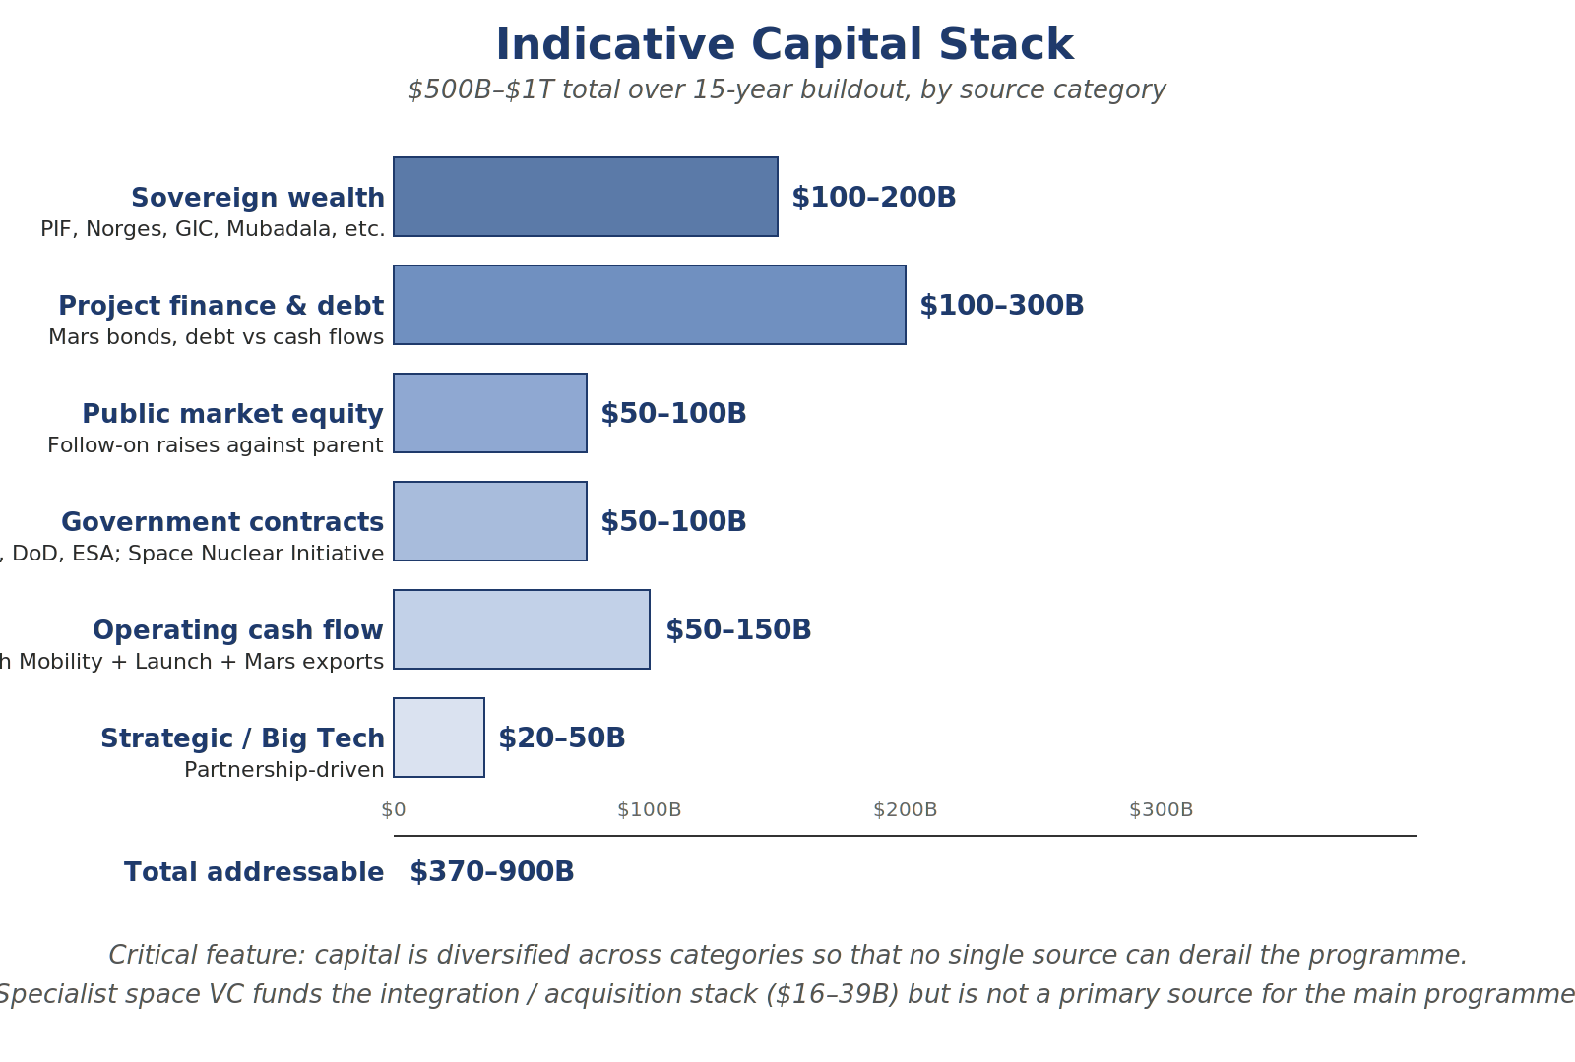
Indicative capital stack across the 15-year buildout.
The $500B–$1T total is diversified across categories. No single source can independently fund the programme; failure of any one source is recoverable but failure of two or more is not.
Sovereign wealth ($100–200B target). Funds with mandates including strategic positioning or technology leadership: PIF, Mubadala, Norges Bank IM, GIC, Temasek, ADIA, ADQ, CPPIB, GPIF. Direct outreach in Phase 0; commitment terms typically include strategic seats and information rights.
Project finance and debt ($100–300B). Largest single category by Phase 3+. Mars infrastructure bonds, debt against propellant production cash flows, asset-backed securities for orbital infrastructure. Credit profile improves as programme matures.
Public market equity ($50–100B). Secondary offerings against the parent entity timed to milestone achievement. Targeted offerings (Mars-class shares analogous to Berkshire B-shares) allow segmented investor bases.
Government contracts ($50–100B). NASA Artemis follow-on, CRS-2, planetary science contracts. DoD interest in lunar logistics. ESA, JAXA, CSA partnerships. Non-dilutive, prestige-positive, but constraining (ITAR, reporting, political dependency).
Operating cash flow ($50–150B). From Year 5 onward, Earth Mobility, Launch, Satellite, and eventually Off-World Industry generate substantial cash flow. By Phase 4, operating cash flow is sufficient to fund continued expansion without external capital. This is the most important single source for long-term sustainability.
Strategic / Big Tech ($20–50B). Google, Amazon, Meta, Microsoft, NVIDIA — partnership-driven equity with associated commercial commitments. Small relative to other categories but disproportionately valuable for strategic relationships.

1.2 Integration Stack Cost
Phase 0 acquisitions and partnerships across the six layers total approximately $16–39 billion. Breakdown:
- High-priority acquisitions (Pioneer Astronautics, Radiant Nuclear, Zeno Power, OffWorld, Starpath, Lunar Outpost): $4–10B
- Strategic equity stakes (Figure AI, Impulse Space, Hadrian, Machina Labs, K2 Space): $5–15B
- Deep partnerships (NuScale, Oklo, X-energy, Honeybee, ICON, Astrobotic): $5–10B
- Reserve: $2–4B
Several targets may not be available at any price (Honeybee under Blue Origin, ICON's NASA contract structure). The plan accepts that some target acquisitions will fail and uses deep partnerships as fallback. See Document 7 for full target company list with funding status.

1.3 Investment Returns by Category
Capital deployed against this thesis flows to four distinct categories with different risk-return profiles:
Category | Risk profile | Return horizon | Failure recovery
Integration entity equity | Highest | 15–25 yrs | Limited; full programme dependency
Layer companies (acquired) | High | 10–20 yrs | Some terrestrial market value
Adjacent infrastructure | Moderate | 5–15 yrs | Strong terrestrial spinoff value
Earth-side spinoff (advanced nuclear, robotics, dry mining) | Moderate | 5–10 yrs | Independent of Mars success

The fourth category — terrestrial spinoff infrastructure that is being built regardless of Mars success — is the most defensible from a pure return perspective. Mars-spec SMRs find terrestrial market in remote industrial sites, disaster relief, high-density compute. Mars-spec autonomy stack accelerates terrestrial humanoid robotics deployment. Dry refining methodology has direct application in water-scarce terrestrial mining. These returns obtain whether or not Mars succeeds.
Capital allocators concerned about the structural concentration or political risk of the integrated entity (see Document 4) may prefer to invest in the supply chain layer rather than the integrator itself. This achieves exposure to the upside without taking the political and reputational risk of association with the dominant operator.

2. Governance Options and Investor Implications
Three corporate governance options are credible. Investor preferences typically differ by structure. Non-corporate alternatives (treaty body, sovereign consortium, CERN-style multinational, public utility) are addressed in Document 2; they are less relevant to private capital deployment but materially affect the political environment.

2.1 Option A — Full Merger (X Industries)
SpaceX and Tesla combine. Three operating divisions: Earth Mobility, Launch, Off-World Industry. Maximum integration; deepest capital pool; unified strategic decision-making. Worth perhaps 3–5 years of programme acceleration over looser structures.
Investor view. Most aggressive growth profile. Highest regulatory and political risk: CFIUS, FTC/DOJ antitrust review, ITAR review, FCC review. Realistic timeline 12–24 months from announcement to closing, possibly 30 months with unusual political opposition. Tesla shareholders crystallise through stock conversion; SpaceX shareholders receive Tesla stock in combined entity. Super-voting structure for founder probably 10:1 with sunset after 15 years or Mars milestones.
Suitable for. Sovereign wealth with high risk tolerance and strategic mandates. Founder-aligned strategic capital. Not suitable for institutional pools requiring isolation from controversy or rapid liquidity.

2.2 Option B — Mars Industrial Subsidiary
SpaceX and Tesla remain separate. New entity (Mars Industries) jointly capitalised by both with outside investors taking direct equity. Subsidiary has own board, management, capital structure; draws on engineering, manufacturing, IP from parents under structured commercial agreements.
Investor view. Most attractive structure for institutional capital. Risk isolated from parent businesses. Direct equity in Mars activity without exposure to Tesla's consumer markets or SpaceX's defence work. Easier path for sovereign and strategic investors. 6–12 months faster setup than merger. Coordination friction across parent boundary partially compensates for governance benefits.
Suitable for. Most institutional pools. The realistic structure if regulatory or shareholder issues make Option A unworkable, which is materially probable.

2.3 Option C — Programmatic Alliance
SpaceX and Tesla remain fully separate. Formal alliance defines shared technical standards but capital and ownership separate. Each company invests in own Mars-relevant capabilities. Outside investors capitalise companies in broader stack that fit the alliance's standards.
Investor view. Slowest of the three options, probably 5–10 years slower than Option A. No unified capital pool large enough for the full $500B–$1T programme. Capital fragmentation prevents the integrated strategic decisions the compression moves require. Closer to conventional space-industrial structure that 50-year baseline assumes.
Suitable for. Investors taking targeted positions in specific layer companies rather than betting on the integrated thesis. The de facto current state of the industry.

3. Milestones and Falsification Markers
The programme should be evaluated against quantitative markers. Capital allocators should treat these as the programme's own admitted thresholds and require milestone-gated deployment rather than blind commitment.

3.1 Phase Targets (if base case obtains)
Phase | Year | Capital deployed | Headline marker
Phase 0 | 2 | $50–100B drawn | 10+ acquisitions, $200–300B committed
Phase 1 | 4 | $100–200B drawn | Starship 50/yr, Optimus 10,000/yr
Phase 2 | 7 | $300–400B drawn | ISRU pilot operational on Mars
Phase 3 | 12 | $400–600B | 50,000+ Optimus on Mars, 30+ MW power
Phase 4 | 25 | $700B–$1T | ~90% local mass, GW power, trade established

3.2 Falsification Markers (when capital should pause)
Phase 1 marker (Year 4). Starship production below 25/yr or Mars-spec Optimus production below 5,000/yr signals manufacturing scaling failure. Timeline extends 3–5 years; Phase 2 should be re-planned. Capital allocators should pause new deployment pending revised plan.
Phase 2 marker (Year 7). 2028 and 2030 precursor missions failing to demonstrate ISRU at pilot scale, or robot loss rate above 60% per window, indicates the autonomy or surface-environment assumptions are wrong. Phase 3 should be paused; capital should not be deployed against an architecture that may need rework.
Phase 3 marker (Year 12). Localisation below 15% (versus 30% target) or fewer than 20,000 Optimus units operational indicates the long-term economic case has weakened materially. Phase 4 should be re-planned at smaller scale; investor expectations should be reset.
Capital marker. Cumulative drawn capital below 70% of plan with no clear path to closing the gap is the warning that the programme is running on unsustainable burn. Programme should slow rather than continue at full rate; investors should expect revised terms.
Political marker. NSTM-3 cancellation, hostile administration, planetary protection lockdown, or antitrust action against the operating entity each materially impair the programme. Investors should expect substantial mark-down in such scenarios.

3.3 Probability Discipline
Investors should not assign confident numerical probabilities to 25-year outcomes. Directional discipline:
- Base case (25-year aggressive timeline executes). Less than 50% probability on the plan's own terms. Eight independent compression moves executing consistently for 25 years is rare in programmes of this scale.
- Conservative case (30–35 years, partial scope). Higher probability than base case. Most plausible single outcome.
- Pessimistic case (programme stalls or fails after $200–500B deployed). Material probability. Historical base rate for serious Mars plans is universal failure.
- Optimistic case (faster than 25 years or larger scope). Low probability. Requires unbroken favourable execution across multiple variables.
A reasonable risk model assumes substantial probability mass on the conservative and pessimistic cases. Aggressive position sizing on the base case alone is inconsistent with the historical record and the underlying execution dependencies.

4. Risks Material to the Capital Deployment Decision

4.1 Capital Discontinuity
The most likely failure mode is gradual rather than acute. Capital flows generously in the first five years, the buildout proceeds, and then in years six through ten — when costs are highest and visible Mars output is still modest — sovereign appetites shift, public markets close, and the programme cannot raise the next $100 billion tranche. The programme does not collapse spectacularly; it slows. Year-over-year deployment drops, milestones slip, the team contracts, and the 25-year programme becomes a 35- or 40-year programme that may or may not finish.
This is how most large industrial programmes that fail actually fail — through gradual loss of momentum. Mitigations are diversified capital sources, milestone-gated commitments, and visible Earth-side spinoff revenues. None is fully effective. Capital allocators should expect substantial probability of discontinuity around Years 6–10.

4.2 Technical Surprises
Mars-spec robots may fail at substantially higher rates than expected. The autonomy stack may not operate the surface industrial base without continuous human oversight that is impossible at light-lag distance. ISRU may work technically but not at industrial scale. Each is addressable through the precursor programme, but each is a meaningful risk to the headline timeline. Capital allocators should expect at least one major technical surprise during Phase 2 that requires architectural rework.

4.3 Stranded Infrastructure
A specific failure-after-success scenario: programme reaches Year 12 having deployed $400B+ in capital and established Phase 3 operations, then capital availability deteriorates and Phase 4 maturation cannot complete. The wreckage is substantial — abandoned robots on Mars, partially decommissioned reactor sites requiring permanent monitoring, a degrading communications constellation, evacuated humans. Total stranded capital could be in the $500B–$1T range. The historical pattern of large industrial programmes shows substantial fraction of capital deployed before completion is sunk if completion fails.

4.4 Concentration and Political Risk
A trillion-dollar enterprise dominating launch, autonomy, and off-world resources concentrates economic, technical, and political power at a level the modern world has rarely seen. Antitrust action becomes politically charged but materially probable. Reputational risk from association with the operating entity is non-trivial, particularly for institutional investors with ESG mandates or political exposure.
Document 4 (Case Against) develops the full structural critique. From a pure investment standpoint: position sizing should account for the probability that institutional or political pressure forces operational changes that materially affect returns. Investors who cannot tolerate this risk should consider supply-chain layer exposure rather than integrator exposure.

4.5 Founder Succession and Key-Person Risk
The integrated entity, particularly under Option A, is substantially controlled by a small number of individuals. Founder succession during the buildout period would be highly disruptive. The succession plan, if any, is not transparent. Mitigations (independent boards, sunset provisions on super-voting structures) are real but partial. Capital allocators should price founder risk explicitly rather than assuming continuity.

4.6 Failure-After-Success Scenarios
Beyond programme failure, several scenarios involve programme success producing outcomes that materially affect investor positions:
- Corporate capture of off-world activity. Operating entity reaches Phase 4 successfully but its structural position becomes politically untenable. Antitrust action breaks up integrated structure; capital recovery uncertain.
- Militarisation of cislunar infrastructure. Defence integration becomes politically dominant; entity becomes targeted by international counter-positioning. Civilian-side returns compromised.
- Political fragmentation between Earth and Mars. Mars residents develop political identities incompatible with corporate governance; settlement becomes contested terrain; trade becomes politicised.
- Ecological contamination event. Containment failure releases viable Earth microorganisms into Mars surface environment; political and regulatory response substantial; valuation impact severe.
Each of these has moderate probability over the 25-year horizon. None is uniquely the basis for not investing, but all should be priced into expectations.

5. Recommended Posture

5.1 Position Sizing
Given the probability discipline above, this should be treated as a venture-style allocation — meaning, an allocation where total loss is a real outcome and the upside scenarios involve patient capital over 15–25 year horizons. Position size should be set against the worst plausible outcome (substantial loss after $200–500B sunk), not the headline scenario.
For most institutional pools, this implies single-digit percentage allocation rather than concentrated exposure. Sovereign wealth funds with strategic mandates may rationally take larger positions, but should expect the financial-return component to be only part of the rationale.

5.2 Deployment Structure
Milestone-gated deployment rather than committed capital. Specifically:
- Phase 0 commitment: 20–30% of allocation, contingent on satisfactory governance terms.
- Phase 1 tranche: additional 30–40%, gated on Year 4 markers.
- Phase 2 tranche: remainder, gated on Year 7 markers (ISRU pilot success).
- Phase 3+ deployment: only against demonstrated localisation trajectory.
This structure provides early-phase capital discipline and limits exposure to the most common failure mode (gradual capital starvation with sunk costs).

5.3 Layer Exposure Decision
The choice between integrator equity and supply-chain layer equity is the most consequential portfolio decision. Considerations:
Integrator (X Industries / merged entity). Highest upside if programme executes, highest concentration risk, highest reputational and political exposure. Returns concentrated in the operating entity; failure modes affect entire position simultaneously.
Layer companies (acquired in integration stack). Moderate upside, partial risk isolation, exposure to specific technical risks. Some companies (NuScale, Oklo, ICON) have substantial terrestrial market value independent of Mars success.
Adjacent infrastructure (lunar, robotics, advanced nuclear). Returns realised across both Mars success and Mars failure scenarios. Lower upside but materially better risk-adjusted profile for risk-averse capital.
A balanced posture is small integrator exposure (5–15% of Mars allocation), substantial layer-company exposure (40–60%), and substantial adjacent-infrastructure exposure (30–50%). This captures upside while limiting concentration.

5.4 Governance Terms
Capital deployed should require specific governance protections, including:
- Independent board representation proportional to capital contribution.
- Information rights including operational metrics, capital deployment cadence, and risk register reporting.
- Veto rights on specific categories: scope changes outside stated plan, militarisation beyond defined limits, planetary protection compliance changes.
- Liquidity provisions: structured exit options at defined milestones, even if subject to discount.
- Anti-dilution and ratchet provisions appropriate to the milestone-gated structure.
Capital allocators who cannot secure these terms should reconsider whether the deployment is appropriate. A founder-controlled entity that resists standard governance protections is signalling reduced accountability, which the historical pattern of large concentrations suggests will be costly over multi-decade horizons.

5.5 What This Memo Does Not Tell You
This memo treats the Mars programme as a capital deployment opportunity to be evaluated on financial terms with appropriate consideration of political and reputational risk. It does not tell you whether the programme should happen on broader social or ethical grounds. Capital allocators with mandates that include broader considerations — public benefit, ESG, political legitimacy — should also engage Document 4 (Case Against) and Document 6 (Ethical Analysis) before forming a position.
A capital allocator who concludes from this memo that the programme is investable, and from Document 4 that the structural concerns are dispositive, faces a genuine dilemma. The dilemma is not resolved by these documents; it is properly resolved by the capital allocator's own framework for weighing financial returns against broader considerations.

